

MATES Computer Science

**Senior Capstone Project Bi-Weekly Progress Report**

| Project Title | Journal Time! |
| --- | --- |
| Team Members | Shayne Lada, Ava McNabb, Lauren McNaboe |
| Dates Covered by Report | 2/12/24 - 2/23/24 |
| Link to Github | <https://github.com/code-shayne/journal-time-/tree/main> |

# **Summary of Project**

Journal Time! is a web app that allows users to journal and store entries online. The web app would provide prompts or free-journaling options and save all entries to unique user accounts. Users can also track emotions by indicating what they are feeling at the time of journaling. After each entry the user will receive a certain number of points or currency, incentivising journaling. The points can be used to buy accessories within the website such as different prompt packages, website themes, or journaling pets. The journaling pets would be avatars that live on the interface and encourage the user to journal and provide motivational messages. Points could also be used to customize and feed/play with pets. Users can track their journaling progress and view graphs and summaries of their emotions in a separate space on the web app. Email notifications can be scheduled to remind the user to journal or sent if the account hasn’t been used for 2 weeks. This project will encourage journaling, which is a useful practice for mental health and wellbeing. It will also make the process more accessible and fun for the users.

# **Summary of Progress this Period**

We created an html file for the main webpage, store, tracking, and entries pages. We also created a css style sheet as reference for the aesthetics of the webpages. The result is the basic layout of our website. There are buttons, text boxes, containers, etc. that will be displayed on the final web app. The features don’t have functionality yet. Several tutorials were also followed and understood by each group member. The basis of html and css coding was gathered from these and put to use for the initial layout.

# **Detailed Progress this Period, separated by Team Member**

Shayne - 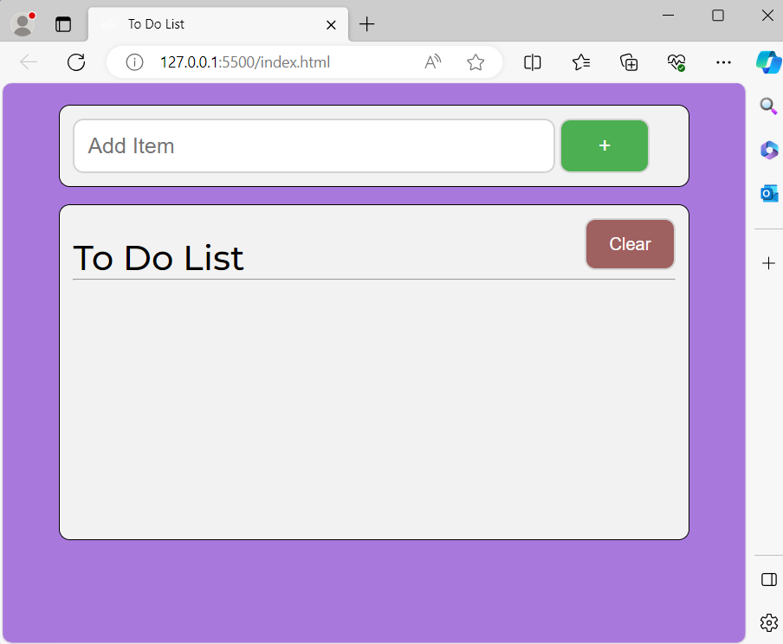

Tutorials

* I followed a web app building tutorial that taught how to make a basic todo list using html, css, and javascript. I completed the html and css portions and created the pictured todo list. We may use python for front-end functionality instead of Javascript, so I have not yet watched the javascript portion of the tutorial.

link: <https://youtu.be/y51Cv4wnsPw?si=v-g09A8nCrRLEscZ>

* I started a codecademy course called Learn HTML and completed 2 of the lessons. It taught the basics of html and the syntax for common code which assisted in the html I did for Journal Time!

link: <https://www.codecademy.com/enrolled/courses/learn-html>

Code

* I created an index.html file and laid out the basic format for the home page by replicating the todo list tutorial I followed.
* We also created html pages for the entries, tracking, store, and login tabs of the website.
* Css was used to design each of the pages with different colors, styles, fonts, etc.
* The home page has placeholder prompt options and buttons that don’t have actual functionality yet. During this sprint I focused on laying out the web app for future work with javascript and/or python.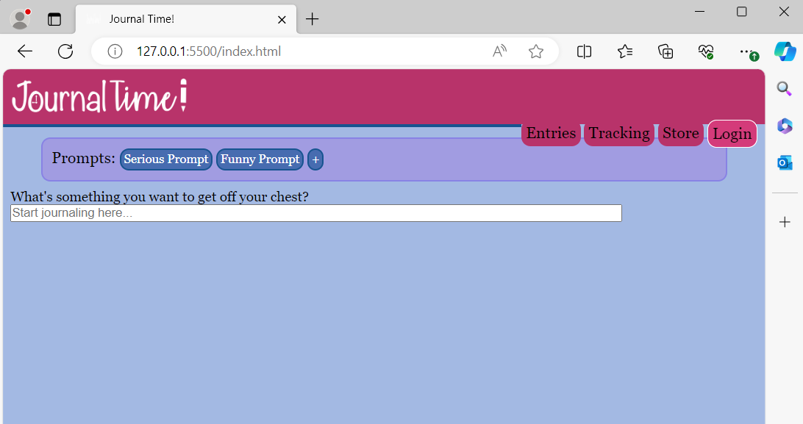

Design

* I created basic wireframes in Adobe XD to create a visual to base the html off of.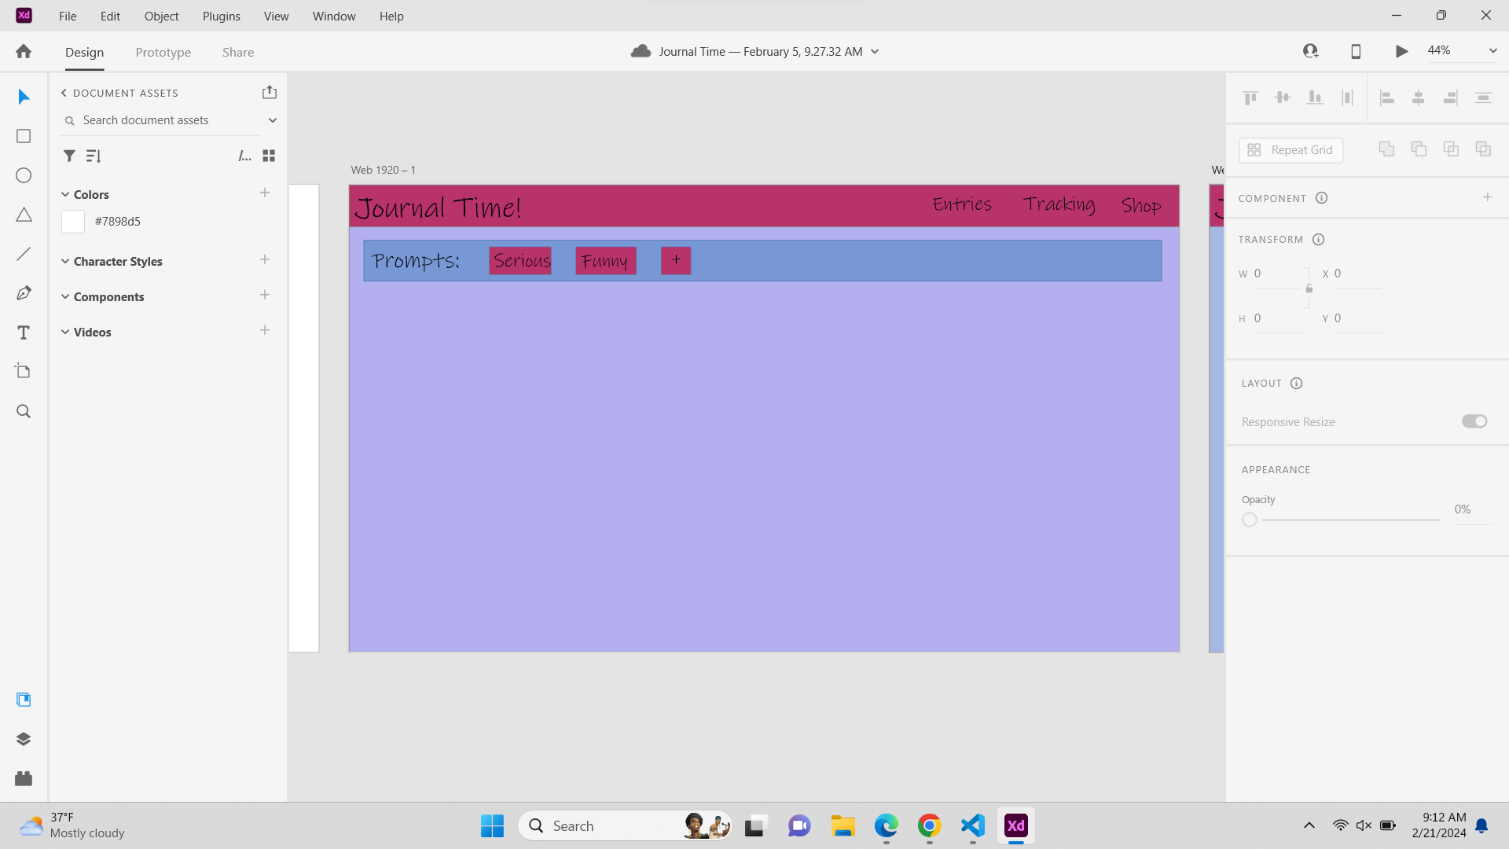
* I enlisted the help of my personal graphic designer (my mom) in the creation of our logo. We went for a handwritten font to reference the nature of regular journaling while also tying in some of the elements of the name with the clock in the O. Personally, I most enjoy the pencil creating the exclamation point at the end. The logo is in black with a transparent background but the font can be changed to white by inverting the colors in css

Lauren -

Tutorials

* I started a Codecademy course for HTML, CSS, and GitHub Pages. I only did a little bit of the HTML portion as I figured it followed a relative pattern; if I needed to format a specific thing I figured I could use Google.

link: <https://www.codecademy.com/enrolled/paths/learn-how-to-build-websites>

* After I moved on from the HTML lessons, I enrolled in a CSS specific course. I did 40% of it and learned a lot about actually styling the website. I helped me create a stylesheet and know the specifics of what makes a stylesheet actually good.

link: <https://www.codecademy.com/enrolled/courses/learn-css>

* I also started a SQL course for creating a database. Since I am working on the login system, I also decided to work on the database.

link: <https://www.codecademy.com/enrolled/paths/design-databases-with-postgresql>

Code

* I created a stylesheet in CSS and modified the SCSS sheet that Shayne made.
* I uploaded a custom font from Google API to use on the whole website.
* I started working on Python code to make the Login buttons actually functional. I made two functions (login() and signup()) that need to actually be implemented in buttons, but I’ll figure that out soon.

Ava -

Tutorials

* I worked on a JavaScript course on Codecademy, and got about 40% of the way through. I learned basic syntax and methods in Javascript, and worked on defining functions (which is mainly the use in our project).

link: <https://www.codecademy.com/enrolled/courses/introduction-to-javascript>

* I also started taking relevant lessons in the Back-End Engineer path on Codecademy. I learned about embedding Javascript into HTML/CSS. I jump around in this one a lot, because the relevant information is somewhat scattered with other lessons.

link: <https://www.codecademy.com/enrolled/paths/back-end-engineer-career-path>

Further Research

* I have been looking into possibilities surrounding the benefits of using Python vs. Javascript to make our website functional
  + some websites use both to handle traffic (JavaScript for client side and Python for server side)
  + Python is better for large data files and CPU intensive tasks, whereas JavaScript can be faster for the user
  + JavaScript is considered to be more scalable
  + Web apps built with JavaScript tend to be faster, even if Python is more efficient
* I have also been looking into smoothly connecting the frontend and backend with each language to minimize errors or bugs in the code
  + using <script> to embed code in an HTML/CSS file
  + separating JavaScript functions into separate files and referencing a file in the index.html
* Currently beginning to try out snippets of code to see what works the most efficiently
  + created test JavaScript file in the “ava” branch - yet to commit code to make it functional

# **Difficulties Encountered this Progress Period**

There were a few issues in the code that were solved with internet searches. For example, the links to other local pages were not behaving correctly so we removed their button aspects and added more stylizing in css for the plain links instead. We created login and sign up functions, but couldn’t connect them to the html pages they needed to go on (problem for next week). We are still in the process of deciding whether we want to use Python or JavaScript to power our web app. Overall, we didn’t have too many pressing issues that couldn’t be solved with a google search.

# **Updated Trello Board and Discussion**

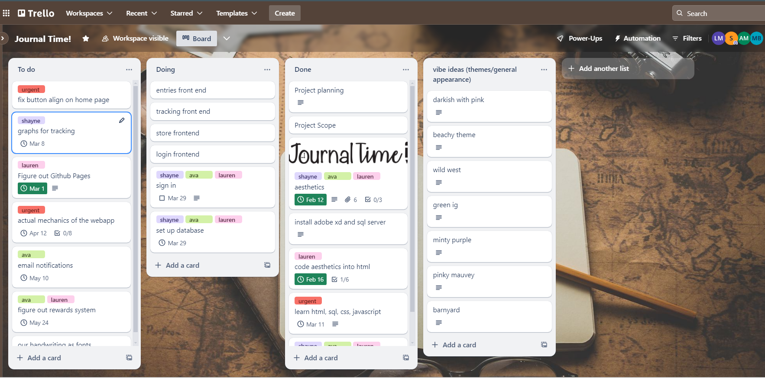

<https://trello.com/b/5P60HsFp/journal-time>

We finished learning how to use these coding languages, wireframing, and coding the main aesthetics of the website in using HTML and CSS. Now, we are working on creating the sign in system and the database to store user information and past entries. We still need to work on hosting the website somewhere, as it is only local right now.

# **Tasks to Be Worked on in Next Progress Period**

Shayne -

* create html and css framework for other pages of the website besides the home page
* fix aesthetic bugs in current code
* add more aesthetics and detailed frame

Lauren -

* figure out how to connect Python commands with buttons when clicked
* create more Python code to add functionality to the website
* work on creating a database that stores usernames and passwords and encrypts them

Ava -

* working on backend as well
* creating Python and JavaScript (?) code to add functionality
* adding functionality to buttons

# **Additional Information**

We decided we might do Python for front-end functionality instead of Javascript because we realized it was possible after looking over last year’s project repositories. We’re still not totally sure so we were a little held up on that decision. Also we need to delegate tasks and concretely decide who is doing what parts better for the following sprints.